32.39: a) The laser intensity 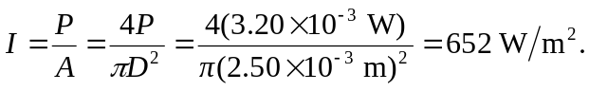
But 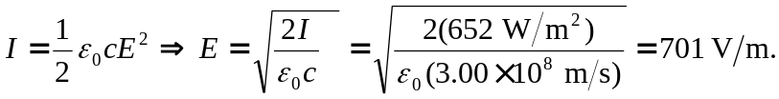
And 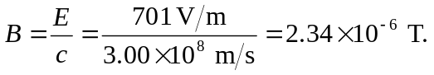
b) 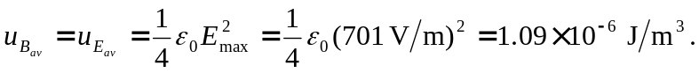 Note the extra factor of since we are averaging.
c) In one meter of the laser beam, the total energy is:

